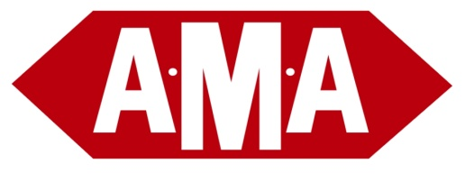

AMA Transportation Company, Inc.

FREEZABLE SHIPMENT POLICY

For those customers who ship products that must be protected from freezing while in transit, you MUST take precautionary measures to make sure your product is protected.
Here are some crucial reminders/suggestions:
- In a clear and conspicuous place on the bill of lading you must notate: “PROTECT FROM FREEZING”. The print must be large and distinguishable from all other print on the bill. Please highlight and bold the print.
- Tag the actual freight as “FREEZABLE” – when and if possible.
- Please refrain from shipping “FREEZABLE” product on a Friday, to prevent the freight from sitting in a cold trailer or warehouse over the weekend.
- If you need protect from freeze to a partner service point, please contact your sales rep for clarification.
Other Important Guidelines:
- It is impossible to protect freezable shipments while freight is in transit.
- Freight cannot be designated “temperature specific” we cannot regulate temperature.
- In particularly cold weather, AMA may elect to NOT move freezable shipments.
- There is an account specific fee for handling freezables, consult your sales rep.
- Any shipments originating or destined to ANY Maine points will NOT be protected from freezing.
Line Haul Specific:

When in transit we depend on the movement of the freight to protect the product. During the night we load freezable shipments into a hot box until the morning. This is temperature regulated to around 40 degrees. During the line haul process, hot-boxing does not happen, and the freight is not protected from freezing aside from the movement of the freight. For this reason it is recommended that you try not to move freight through the line haul process when possible.

