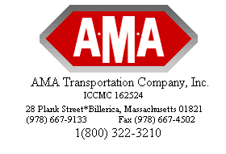
Notice of General Rate Increase
Nov 15, 2022
Dear Valued Customer:

AMA Transportation Co., Inc. is dedicated to meeting and exceeding all the service needs of both you – our customer, and as importantly – your valued customers, with quick dependable and flexible L.T.L. and truckload freight services. In order to fulfill our continued commitment to provide the premium quality service our customers require and deserve; we must implement a general rate increase as follows:

- Class rate base tariffs: Increase on average of 4.9% based on the weight break and lanes. Applicable on LTL – 0-20M & minimum change.
- Minimum charge floors: Increase ranging from $4.00. (rounded to the nearest .50 cents)
- Unit rate tariff: per unit $4.00
- All customers under a contractual arrangement will be re-evaluated on their anniversary date.

Effective Date: November 01, 2022

This rate adjustment is based on the extreme short supply in capacity and severe labor shortages in all aspects of today’s business environment. In addition to escalating operating cost in insurance, security, healthcare, equipment upgrade, communications, taxes, labor increases, and increased government regulations. Please be aware that we are working diligently on all internal efficiencies so we can sustain long-term value and top quality to our customers.

We thank you for selecting us as your transportation service partner. We appreciate and value your business and look forward to our future service partnership. We remain committed to our customers and our ability to provide a positive service reflection of them.

If you have any questions or need updated information, please call your sales rep at 1-800-322-3210.

Best regards,

Traffic Department
AMA Transportation

